29.67: At point 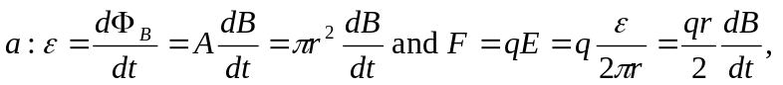 to the left. At point , the field is the same magnitude as at since they are the same distance from the center. So 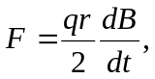 but upward.
At point 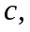 there is no force by symmetry arguments: one cannot have one direction picked out over any other, so the force must be zero.

